A

Project Report
O n

Project Title

Submitted By:
Your Name

In partial fulfillment for the award of the degree of

YOUR DEGREE NAME
In

College Name Or University Name

YOUR UNIVERSITY NAME
DATE-YEAR

Certificate

This is to certify that (YourName) and research report entitled “ eg .Project Title.” is approved and is acceptable in quality and form.

_______________
Faculty Guide

date:________________
Place: :_______________

DECLARATION

I hereby declare that the project report entitled:

A Research Report on “Project Title.” submitted in partial fulfillment of the requirement for the degree of BBA/MBA, is my original work and not submitted for the award of any other degree, diploma, fellowship, or any other similar title or prizes.

Place:

Date: _________

ACKNOWLEDGEMENT

I wish to express my gratitude to all that concerned persons who have extended their kind help, guidance and suggestions without which it could not have been possible for me to complete this project report.

I am deeply indebted to my guide Mr. GUIDENAME for his valuable guidance and support at all time.

My sincere thanks to all those people who has provided me all the necessary information throughout this research report has been successfully completed at time.

INTRODUCTION
Financial management has always vital and an integrated part of business management .Financial management is concerned with the planning and controlling of the firms financial resource. It is often said that the financial management has received less emphasis as compared to topics like production and marketing. However the task of financial planning and controlling will assume relative more important role then in the past due to certain changes that have taken place or will take place in economy . Factors such as increasing pace of industrialization, technological innovations land inventions, raising price levels, increasing influence of government in financial matters etc.
Definition of Accounts Receivable Management:
“Trade credit arises when a firm sales its products or services on credit and does not receivable cash in immediately”.
“A firm investment in accounts receivable depends upon volume of credit sales and collection period”.
Receivable Management:
When the firm sells its products or services and do not receive the cash for it immediately, the firm is said too have granted trade credit to the customers. Trade credit, thus, creates receivables or book debts which the firm is expected to collect in the near future.
Account Receivables:
Receivables may be viewed as cash fund asset for any purpose which looks behind the period of time in receivables on the books will mature into cash.
Northerly, every organization will go for offering credit and these may be gives raise to increase their customers as well as extra fund is acquired as the facet of interest. These receivables come under current assets as they sooner are converted into cash. Accounts receivables are the second most liquid form of assets of the firm. The receivables come into being as credit sales and constitute as one of the largest assets. Skill full administration of the receivables management is therefore of prime
importance to the business. The very reason of credit sales is to expand sales volume and if too debit is maintained by the company in the approval of customer credit purchases many sales may be lost that would other wise contribute to the profits of the firm.
Trade credit is considered as an essential marketing tool, acting as a bridge for the movement of the products through production and distribution stages to customers. When the firm sells its products or services and do not receive the cash for it immediately, the firm is said too have granted trade credit to the customers. Trade credit, thus, creates receivables or book debts which the firm is expected to collect in the near future.
Receivables constitute a substantial portion of current assets of several firms. In India, trade debtors, after the inventories, are the major components of the current assets. They form one-third of the current assets in India. Granting credit and creating debtors amount to the blocking of funds. The interval between the date of sale and the date of payment has to be financed out of the working capital. Thus, trade debtors represent investment. As substantial amounts are tied up in trade debtors, in needs careful analysis and proper management.
Collection:
The purpose of collection operations is to maximize collections and minimize the loss of future trade. Collection effectiveness is mainly influence, how every.
- The classification of debtors.
- Credit policy as influenced by the type of business and its goods, profit margin and competitive and
- The type of records to be used to monitor collection procedures.
Classification of Customer Accounts:
An analysis of collection from accepts accounts provide a useful measure of the potential loss in the various customer classifications. Customer accounts may be classified in various categories.
- Government
- Prime or excellent large. Well-established firms.
- Good firms that are not large and have not yet established excellent credit reputations.
- Restricted: firms that are limited to a definite credit line and
- Marginal high risk accounts which must be watched.
Receivables are a border line item which may be classified as either a cash fund asset or an operating fund asset according to the purpose for which the classification is designed.
Moreover, receivables may be viewed as cash fund asset for any purpose which looks beyond the period of time in which receivables on the books will mature into cash.
Northerly, every organization will go for offering credit and these may be gives raise to increase their customers as well as extra fund is acquired as the facet of interest. These receivables come under current assets as they sooner are converted into cash.
OPERATING CYCLE

RAW WORK IN FINISHED SALES DEBTORS.
MATERIALS PROGRESS GOODS

Importance of Cash:
In starting of a business enterprise, the initial investment is still required to be made in cash and all fruits of the operation of a business enterprise are also ultimately drawn in the form of cash by way of dividend.
Cash participate a major role for further business expansion to generate and purchase fixed assets like land and buildings, plant and machinery.
Motherly cash has to be invested in the business for the purpose of generating the important elements of cost viz., materials, wages and expenses.
Analysis Frame Work:
Classifications of Collection Operations:
- Preparation of Aging Schedules.
- Credit Sales to Account Receivables Statement.
- Collections to Accounts Receivables Statement.
The whole calculation part data has provided by the employees of Finance Department as secondary source of data and there was no scope has given me to look into original statements. When we step into the organization, we will see a wall hanger consists of “A LITTLE FROM EVERYONE CAN SAVE A LOT”.
Analysis of Aging Schedule:
The company prepares monthly aging schedule to monitor its book debts. The debts outstanding are broken down into branch wise entries. The aging schedules for the past three years have been thoroughly analyzed to come out with average outstanding days of the book debts of the company. On an average the outstanding days of the book debts in the company is as follows overdue less then 30 days, 30 to 60 days, 60 to 90 days, 90 to 180 days, 180 to 300 days and above 360 days respectively.
These reports are prepared especially for the extended over due accounts. The basic reason is to develop a file of customers who require special attention either in the form of statement, letters or other collection activity.
Accounts Receivables Turnover Ration:
- Credit sales divided by ending accounts receivables and
- Accounts receivables divided by credit sales time.
365 days the first formula gives the number of times the correct balance of receivable is collected during the year, while the second formula gives the average number of days the current balance is expected to remain outstanding before it is collected.
Collection Ration:
This is the ratio of monthly collections to the accounts receivables outstanding at the first of the month to ratio sales to receivable and collection to receivable is closely related.
What actually credit will create?
- Company position.
- Protection from competition.
- Buyer states and Requirements.
- Dealer Relationship
Credit Policy and Practices at Amara Raja Power System Ltd.,
The sales of the company, Amara Raja Power System go on cash as well as credit terms. The trading division of the ARPSL limited sells its products, which it receives from the factories on a credit period of 45 days, through the branches of the company located all over the country. The branches in turn, will see these products to the customers of the company all over the country.
Credit Policy:
There is one way in which the financial manager can control the volume of credit sales and collection period and consequently, investment in accounts receivables it can changes through credit policies.

CREDIT POLICY

Credit Standard Credit Term Collection Cash Discount

It is careful analysis Specifies of the Lower collection
Risk Duration influences lower
Investment in
Receivables and Vice-Versa.

Credit Standards:
Credit standards are criteria to decide the types of customer to whom goods could be sold on credit. If a firm has slow paying customer its investment in accounts receivables will increase the firm will also be exposed to higher risk of default.
Credit Terms:
Specify duration of credit and terms of payment by customers investment in accounts receivables will be high if customer are allowed extended time period for making payment.
Collection Efforts:
Collection effort determine the actual collection period. The lower the collection the lower the investment in accounts receivable and vice-versa.
Goals of the Credit Policy

Stringent Credit Policy Lenient Credit Policy

Less Credit to customer as More credit to
Results decrease in sales its leads increase in sales

If there are any changes in credit policy there will be change in the Volume of credit sales.
- Default risk (or) Bad debts.
- Costs
- Average collection period.
- Looks for the period of presence of the customer in the business.
- Looks for the character of the customer i.e., his willingness to pay the moral factor is of considerable importance in credit position.
- Look for his ability to pay. This is evaluated by his financial position and the bank guarantee given by him.
Based on the above factors the company analyses the customers and determine the credit limit to them. Every six months, the company goes for the review of the customers.
When a customer is found to be regular in paying the dues with in 30 days the company may go for increase in the credit limit for the customer. In a small way, the new customers are taken into consideration and given the credit.
Collection Procedures:
The company follows a system of centralized control and decentralized collections. The company does not employ any collection agency for its collection activities. The trading division receives a statement of sales and outstanding daily from all the branches in the country, to initiate appropriate actions. The sales offices are engaged in collection activity and the collection is done through CMP account and through Bank Cheques.
Monitoring Book Debts:
The company classifies its book debts based on the number of outstanding days in the given following way:

OUTSTANDING DAYS | DEBTS CATEGORY
MORE THAN 300 DAYS | BAD DEBTS
BETWEEN 180 TO 300 DAYS | DISPUTES
BETWEEN 90-180 DAYS | DOWBTFUL DEBTS
BETWEEN 0-90 DAYS | GOOD DEBTS.

INDUSTRY PROFILE
Power Systems:
Power supply in a buffer circuit that provides power with the characteristics required by the from a primary power source with characteristics incompatible with the load. It makes the load compatible with its source.
A power supply in sometimes called a power converter and the process is called power conversion. It is also sometimes called a power conditioner and the process is called power conditioning.
A switching mode power supply is a power supply that provides the power supply function through low loss components such as capacitors, inductors and transformers and the use of switches that are in one of two states on or off. The advantage is that the switch dissipates very little power in either or these two states and power conversion can be accomplished with minimal power loss, which equates to high efficiency. The terms switch mode was widely used for the type of power supply until Motorola, Inc., who used the trade mark SWITCH MODE TM for products aimed at the switching mode power supply which seems to be the popular term. PSMA does not define either switching mode power supply or switching power supply, but does define switching regulator.
Because of its emphasis on efficiency, switching mode power supply design minimize the use of loss components such as resistors and uses components that are ideally loss less such as Switches, Capacitors, Inductors and Transformers. The Primary design problem is how to inter connect these components and control the switches so the desired results are obtained. The secondary design problem is to select, design or over come the performance characteristics of less those ideal components.
Power Conversion Circuits are often classified in Four Categories:
Ac, ac coverts (Example:- Frequently changes, Cyclo converts).
Ac, dc coverts (Example:- Rectifiers, Offline converts).
Dc, ac coverts (Also called coverts).
Dc, dc coverts (Also called converts).
The term converter or power converter is called for all these categories are for dc, dc converts only. The meaning is usually clear from the context. All of these converts may be open loop circuits or use feedback to provide regulation.
The scope for this study is dc, dc converts and a special type of ac, dc converts called an offline converter of offline power supply. In offline converters the ac voltage is rectified to dc directly off the ac power line and filtered with no isolation transformers and then processed with a dc, dc converter that provide isolation at the switching frequency. Since the switching frequency is much higher than the line frequency the isolation transformer and output filter or greatly reduced in size and weight. The switching frequency in usually 20 KHz or higher to place any audio noise from the switching beyond the range of human hearing. Regulation of output voltage, Current or power is assumed because that’s where the fun begins. Also the rectification process may or may not include power factor correction or harmonic current suppression technique.
Electric generating capacity in the Americas in 1997 was held primarily by tow countries, the USA and Canada combined those two countries alone accounted for 82% of total power generation capacity in the Hemisphere. Brazil, Mexico, Argentina and Venezuela also have significant amounts of power generation capacity. Canada and Paraguay and by far the largest power exporters in the America. In 1997 Canada exported 46 Twh, mainly to Brazil about 57% of power in the Americas is generated by thermal (Coal, Oil Natural Gas) Plants. The reminder is generated by Hydro power (35%) Nuclear (16%) Geothermal and other renewable (2%).
South America is one of the fastest growing world regions for electricity demand. Hydro Electricity accounts for the larger share or energy consumption in South America that in any other major world region on May 11, 1999, Spain Endesa purchased a 30% share in Chile’s Endesa, Latin America’s largest non stage generator, for $ 1.85 billion. Spain’s Endesa also controls Chile’s power holding company Enersis Argentina and Paraguay jointly own the $ 8 billion, Hydro complex on the Parana River at Corpus.
Eco Electrical will be one of the most environmental friendly / least polluting power plants in the world. A $ 100 million power plant is being built in Trinidad and
Tobago by U.S. based inncogen. Mexico’s power system is controlled by two vertically integrated, state, owned companies CFE and LFC. Mexico’s 700 megawatt Gas fired salamayuca II power plant, the first in the country to be financed by a mix of public and private funds, was due to be completed in late 1998.
Brazil’s power sector is in the midst of a radical change from state to private control. Five Brazilian power distributors are scheduled to be privatized during 1999, according to the Brazilian Development Bank. Brazil’s privatization of its electric power sector in breaking large integrated utility companies line CESP and Electro bras into smelled units and selling off the generation and distribution pieces. Argentina has been attempting to boost productivity in the power sector by transferring assets, including provincial power companies, from the state to the private sector. In April 1997 the argentine Senate passed a bill privatization of Argentina’s Authca I, Embalse Rio Tercero, and (uncompleted) Authca II nuclear plants.
Privatization of Venezuela’s power section kicked off in 1998 with the sale of Sistema Electrics de Nuevo Esparta (Seneca). In late March 1999, Venezuela’s President Chavez announced his intention to privatize state, owned power companies, in May 1999, the Government confirmed that it intended to press ahead with privatization or regional power companies. Currently, state owned companies account for around 80 of Venezuela’s installed power capacity.
Growing demand for electricity through our the Americas especially in countries such as Mexico and Brazil, has helped to foster they interconnection of the regions various electricity sector, the easing of restrictions to international investments and the development of cleaner more efficient power plants.
Approach:
As explained in the introduction, a power supply in a buffer circuit that is place between an incompatible source and load in order to make them compatible. In this section we explore some simple circuits that can be placed between a 12 V dc battery and a 5V dc load them compatible. The buffer circuits are simple in that we will restrict the parts to one each to one each or less of the following parts.
COMPANY PROFILE
Amara Raja power Systems (P) Ltd., was started in the year 1986 with a vision to provide “Complete & Intergraded DC solutions “to customers requirement. The company is situated in 200 acre Amara Raja Complex, Renigunta 7 km. from Tirupati, India with ultra manufacturing & testing facility. Amara Raja Power Systems is a part of Amara Raja Group of companies with its flagship company Amara Raja Batteries Ltd., being the largest manufacturer of maintenance free Value Regulated Lead Acid Batteries in India Ocean Rim and also manufacturing Automotive Batteries in India Ocean Rim and also manufacturing Automotive Batteries with a brand name AMARON.
Amara Raja Power Systems began its operation with first commercial production of Uninterrupted Power supply systems in 1987 in Technical Collaboration with M/s HDR Power Systems Inc. USA. In the year 1989 three store based Battery Charges were added to the product line and ever since, they are the leading manufacturers of custom build Battery Charges in India catering all types of application & Services. Their designs and products are tested and well accepted by leading consultants Viz., Macon, EIL, PGCIL and TCE, RDSO, etc. To cater to a wide range of applications and customers needs, Amara Raja has developed customer built inverter in 1990 for Indian Railways used in the AC coaches. Also they are regular suppliers of charges as per RDSO specifications for traction and signal & Telecommunication for India Railways.
With change in Technology and opening up to Telecom sector, they are quick to adapt to the fast changing scenario. As a result in 1999, Amara Raja has started manufacturing Switch Rectifies (SMR) in technical collaboration with M/s Rectifier Technologies Australia for Telecom applications with expanded, modernized and integrated plant facilities. Today ARPSL is the largest supplier of Switch Mode Power Supply Systems to Core Indian Utilities such as Bharat Sanchar Nigam Ltd., Indian Railway, Power Generating Stations, MTNL, BEL, PUNCOM and HTL. Major MNC’s like Semens, Alcatel, Fujistu, Motorola and Tata Labret and among ARPSL’s Clientele.

With their rich experience & available technology they were closely involved with Indian Railways in developing SMPS based integral power supply systems for S & T Applications. They obtained RDSO approval in 2000 for their SMPS based IPS system and since then they are preferred suppliers of IPS to Indian Railways. Today they provide the complete and integrated DC solutions with manufacturing facility for MF, VRLA Battery, Thyristor based Battery charger, switching mode power supply systems DC / AC Distribution Board, Bus Ducts & associated accessories in a single complex with an experience of more than 15 years in these products catering in power to power & Process, Telecom and Railway Sectors.
About the Founder:
Amara Raja Group of companies are promoted by Sri Ram Chandra N. Galla, a technocrat with B.E (Electrical) degree from Sri Venkateswara University, M.E (Applied Electronics) form Rorkee University and M.S (Systems) form Michigan state university, USA. He has 22 years of experience in various fields of engineering out of which 17 years are in USA. In the design and erection of nuclear and fossil power plants. He worked as a Senior Project Engineer with M.S Dergeant & Lundy, U.S.A (Power Consultants) for above 20 years. Prior to this, he worked as an Electrical Engineer for 3 years.
CMD/ED
Finance Accounts
Chief Finance Officer
K. Suresh
Human Resources
Vice President
Jai Krishna
Supply Chain management
Vice President (SCM)
G. Vijay Naidu
IT
Chief Information Officer
K. Suresh
QMS & QA
Vice President
D. Naran Reddy
Finance Accounts
D.G.M
D. Ramesh Babu

Finance Manager
G. Ramachandra Raju
Debtors Officer
Padmaja
Costing Manager
V. Venkatesh
Commercial Manager
A. Venkatesh
Human Resources
Manager (H.O)
V. Chandra
Sekhar
ADMIN (HO)
Officer
M. Parthasaradhi
D.G.M
B. Damodara Rao
DP & IM
HOD
L. Mahadeva
Logistics
Sr. Officer
R. Chandra Raju
Manager
S. Sathesh
QMD
Manager
K. Subba
Reddy
AMARA RAJA GROUP DEPARTMENTS – HODS ORGANISATION CHART
QA – ARBL
Manager
P.Murali
COSTING DEPARTMENT FLOW CHART
Managing Director
Jayadev Galla

CFO
Gopal Mahadevan

DGM
BSP Murali
Costing Senior Manager
V.GURAPPA NAIDU
-Report analysis
-Profitability Statements
-Leasing with bankers, Auditors & Other officials
-MIS
-Pricing

-Report analysis
-In process records
-finished goods records
-Stock statements
-Scrap register
-Maintenance of PSL
V. Prakash
Asst - II
Production
Officer
G. Chandra Sekhar Naidu

R & D
Project
Maintenance of record for Electrical and Mechanical spares

Non – Production

Corporate Goal:
“The Corporate Goal of the Company is to achieve customer satisfaction through the collective commitment of their employees in design, manufacture and marketing of reliable power systems, batteries, allied products and services.
Corporate Policy:
“The Corporate Policy of the company is to transform its spheres of influence and to enrich the quality of life by building instructions that provide better access to better opportunities, goods and services to more people all the time.
Amara Raja Net Work
Registered Office : Karakambadi, Tirupati
Corporate Operations Office : Chennai
Marketing Offices & Service Centers : Bangalore, Mumbai, Kola,
New Delhi, Hyderabad and Chennai.
Selling Policy:
The company is adopting the policy of direct selling without any intermediates as the product falls under the category of Capital Goods. The company established its base in major cities like Mumbai, Kolkata, New Delhi, My sore, Bangalore and Hyderabad. All these units are fully equipped with experienced staff and infrastructure. ARPS has also widened service network. As a member of Amara Raja Batteries automotive branch’s facilities for its service points to serve the needs of its clientele better.
Amara Raja Power Systems – Facts & Figures:
- Technical collaboration with rectifier Technologies, Australia for Switch mode Rectifiers.
- 1999, 2000 revenue of Rs. 16 Crores for ARPSL and Rs. 132 Corers for ARBL.
- State of the art manufacturing facility at Tirupati. Capital outlay of Rs. 712 millions, Machinery & Testing Rs. 527 millions.
- Received the ISO – 9001 certification in year 1999 and rectified in June 2006.
- Turnover in 2005 – 06 is Rs. 281 millions.
- R & D Center started operation in 1996.
- Implemented an ERP Programme in March 2000 for enhanced operational efficiencies and higher integration of expanding operations and spread of Business.
Awards Received:
‘Best Industry all round performance’ award in 1988 by FAPCCI
- ‘Entrepreneur of the year’ award to Mr. Ramachandra N. Chairman & Managing Director in 1988 by HMA.
- ‘Business Excellence Award’ in 1988 by Industrial Economist.
- ‘Udyog Rattan Award’ in 1999 by the Institute of Economic Studies.
Environmental Programmes:
- Advancement for ISO – 14001 Certification.
- Health monitoring and awareness Programme
- Both Personal and Industrial Safety Programme.
- Start up of EMS implementation Programme.
- Nil discharge and lowest emission awareness and implementation Programme.
- Waste Reduction Scheme.
- Energy conservation Programme.
- Continuous and massive green belt development Programme.
- Ground Waste Collection, Treatment, Storage and Safe Disposal Programme.
- Central Waste Collection, Treatment, Storage and Safe Disposal Programme.
- Personal Health Safe Guarding Programme.
Social Programmes:
- Housing Colony to the Employees is in Progress.
- Total plan 500 families over five years, 108 already commissioned.
- Plant provides Community Hall, Open Auditorium, Recreation Club, Park and Play ground.
- Training Center for Employees.
- Bachelor’s Hostel, Co-Operative Stores and Banks in Operation.
- Roads, Water Supply, Street Lights, Greenery, Educational and Cultural Activities.
- Enhancement in neighboring villages.
- Awards and Rewards to the Younger Generation for improvement of education.
- Modernization of Public Parks for the full fledged recreation of Children.
Customers:
- BSNL,
- SIEMENS SPCN,
- RELIANCE AND
- L.G.
Competitors:
- Spain Power Systems (P) Ltd., Rajkot.
- Star Vision Power System, New Delhi.
- Hi-Rel Electronics (P) Ltd., Gujarat.
- Power Services, Kolkata.

AMARA RAJA GROUP OF COMPANIES
Amara Raja Batteries Limited:
Amara Raja Batteries Limited was established in 13th , February 1985 and the converted into public limited company in the year 1990. Amara Raja has a strategic tie-up with Johnson Controls Inc. of the U.S.A.
Amara Raja has demonstrated its commitment to offer optimum system solution of the highest quality and has become the largest supplier of Indian utilities such as the Indian Railways, Department of Telecommunications, Electricity Board and major power generation companies.
ARBL comprises of two major division viz., Industrial Battery Division and Automotive Battery division. The total strength of ARBL is around 1350.
ARBL

Industrial Battery Division Auto Battery Division
Railway Coaches

    - Telecom
    - UPS
Industrial Battery Division (IBD):
Amara Raja has become the benchmark in the manufacturer of Industrial batteries. India is one of the largest and fastest growth markets for industrial batteries in the world. Amara Raja is leading in the front, with an 80% market share is stand by VRLA batteries point of view. It is also having the facility for production plastic components.

ARBL is the first company in India to manufacture VRLA (SMF) Batteries. The initial investment of the company has Rs.1920 lakhs, the total land is around 18 acres in Karakambadi village, Renigunta Mandal. The project site is notified under ‘B’ category.
Capacity:
The capacity per the year 2005 – 2006 of IBD is 3, 70,000 cells Per Annum.
Products:
Amara Raja being the first entrant in this industry and has the privilege of pioneering VRLA technology in India. Amara Raja has established itself as a reliable supplier of high quality products to major segments like Telecom, Railways and Power.
Competitors:
The major competitors for Amara Raja Batteries are “Exide Industries Ltd., and GNB”.
Automotive Battery Division (ABD):
ARBL has inaugurated its new automotive plant at Karakambadi in Tirupati on September 24^{th,} 2001. This plan is a part of the most completely integrated battery manufacturing facility in India with all critical components, including plastics sourced in-house from existing facilities on site. In this project, Amara Raja’s strategic alliance partners Johnson Controls Inc., of USA have closely worked with their Indian counterparts to put together the latest advances in manufacturing technology and plant engineering. It is also having the facility for producing plastic components required for automotive batteries.
Capacity:
With an existing production capacity of 5 Lakh units of automotive batteries, the new Greenfield plant will now be able to produce 1 million batteries per annum. This is the first phase in the enhancement of Amara Raja’s production capacity, for this the company has invested Rs.45 crores and the next phase, at an additional cost of Rs.25 crores, for this the production capacity will be increase to 2 million units and
the company has estimated to complete around 3 years, after that ARBL will become the single largest battery manufacturer in Asia. The Fiscal Year 2005 – 2006’s capacity of ABD is 2.2 million number of batteries per year.
Products:
The products of ABD are:
- Amaron Hi-way
- Amaron Harvest
- Amaron Shield
- Amaron Highlife
The plastic products of ABD are “Jars” and “Jar Covers”.
Customers:
ARBL has prestigious OEM (Original Equipment Manufacture) clients like FORD, GENERAL MOTORS, DAEWOO MOTORS, MERCEDES BENZ, DAIMLER CHRYSLER, MARUTI UDYOG Ltd., Premier Auto Ltd., and recent acquired a preference supplier alliance with ASHOK LEYLAND, HINDUSTAN MOTORS, TELCO, MAHINDRA & MAHINDRA and SWARAJ MAZDA.
Competitors:
- EXIDE, PRESTOLITE, and AMCO.
Features and Benefits of the Product:
Absorbed Electrolyte --- Safe, no free acid
Sealed Construction --- Spell proof and leak proof
Oxygen recombination cycle --- No external gassing
Resealing safety valve --- Explosion proof and pressure regulated
Copper core terminal --- Improved connection
Special hybrid alloy --- Deep cycle capability
Factory charged --- Ready to use
Automotive Battery Division (ABD):
- OEM (Original Equipment Manufacturing)
  - Tata Motors Limited
  - Hindustan Motors Limited
  - General Motors Private Limited
  - Mahindra & Mahindra
  - Hyundai Motor India Limited
  - International Tractors limited
- Private Labels:
  - Lucas Indian Service Limited
  - AC Delco
  - MICO – BOSCH
- Exports:
  - BOSCH, Japan
  - Fiamma, Italy
  - Pollux Distributos Inc., Philippines
Mangal Precession Products Private Limited1 (MPPL1):
MPPL1was started in the year (1996-1997) to produce battery components like “copper connectors, copper inserts, hardware required by ARBL and ARPSL”.
It is having all the “sheet metal processing machinery”, it starts from “sheet cutting to final painting with punching, bending, welding, phosphate and power coating processes”.
The plant is locating at Karakambadi Village, Renigunta Mandal, Tirupathi and is registered as an ancillary unit to ARBL and ARPSL. The operations of the company are brisk and satisfactory.

Mangal Precession Products Private Limited2 (MPPL2):
MPPL2 was started in the year (1996 – 1997) to produce battery components like “copper inserts, hardware required by ARBL and ARPSL”.
The unit is located at Petamitta Village, Talapulapalli Mandal, Chittoor at a distance of 65kms from Amara Raja group of companies, Karakambadi,
In this the aim is to develop backward villages. It will also produce quality hardware for “Automobile Manufacturer Company” up near Chennai.
Amara Raja Electronics (Pvt.) Limited:
It was recently established in 2000. It produces electronic card and power distribution broads for UPS and inverters.
Product Profile:
Type of VRLA batteries manufactured in the Industrial Battery Division and their applications are as follows:
1. Power Stack:
Applications: Power plants, Process and service industry, Railways, Telecommunications, Uninterruptible Power Supply (UPS) systems, Electronic Private Automatic Branch Exchange (EPABX), Defense (Onshore & Offshore wireless communication cellular Radios), Motive Power.
2. Kombat (UPS Battery):
Applications: UPS, EPBX, Engine Starting, Emergency lighting, SPV, Portable Power, Security Systems.
3. Brute
Applications: Forklifts, Pallet trucks, Stackers, 8 Platform trucks.

PRODUCT PROFILE
Conventional Battery Chargers : Up to 220 V / 500 A 24 V / 2000A
Switch Mode power supply (SMPS): Modules of 48V / 25 A up to 200A And 48 V / 100 A up to 3200AModules of 110V / 15 A
- Integrated Power Supply (IPS) Systems specially
- Designed for Railway Signaling & Telecommunications.
- DC / AC Distribution Boards.
- Charge / Discharge Units for Battery Information

NEED FOR THE STUDY
The main purpose behind this project is to know how to debts were procured by Amara Raja Power Systems Limited. The study is on internal financing pattern of the debtor’s receivables relating to the wing of cash management to achieve more customers with better excellence of policies relating to domestic economy of the company. Therefore, for clear analysis is to be made to know the reasons & find out the measures to be taken to make the organization more successful in acquiring debt amounts from its customers.
SCOPE OF THE STUDY
An extensive study is done on the blocking up of receivables and its retaining activities, and the factors determining these notes receivables. The study concentrates on the liquidity position of the firm, and a brief study is made on the techniques used by the firm.

OBJECTIVES OF THE STUDY

The main objective of the current study is the company performance towards receivables action executing in ARPSL. The prime objective is to analyze and evaluate the receivables management and its performance in ARPSL.
The following were the objectives of study were:
- To know how the receivables were managed.
- To analyze to what extent they were offering credit.
- To know who were the major defaulters.
- To know how much extent of cash is blocked as bad debts.
METHODOLOGY
Methodology refers to the way adopted for collecting information for the purpose of drawing inferences. Methodology plays a vital role in the analysis of the study.
Methodology is the science of system and a method of conducting a research work.
Data Collection:
The study is depends on primary and secondary data from various sources:
Primary Data:
First hand information was collected from experts of finance department, on their course of actions towards collections.
Secondary Data:
The Secondary data that is required for the studies is collected from the Schedules, past notes, Budgets, through company websites and other statements provided by Finance Department of AMARA RAJA POWER SYSTEM LIMITED.
LIMITATIONS
1. The data used is gathered mainly through secondary sources and no independent verification has been done on the same.
2. The time series analysis of ratios ha been attempted with no effects being given to inflation.
3. Detailed analysis could not be carried for the project work because of the limited span of time
4. Only five years financial reports have been considered i,e., from 2005 to 2009.
4. And the total statements are given as secondary sources and they doesn’t provide to go through scrutiny of those statements.
DATA ANALYSIS & INTERPRETATION

Analysis of Aging Schedule:
The company prepares monthly aging schedule to monitor its book debts. The outstanding are broken down to branch wise entries. The going schedules for the past three years have been thoroughly analyzed to come out with average outstanding days of the book debts of the company. On an average the outstanding days of the book debts in the company is as follows:
Outstanding period | Outstanding Receivables | % of Total  Outstanding receivables.
Not due | 154,729,841 | 39%
0-30 | 78,228,992 | 19.7%
31-60 | 22,432,025 | 6%
61-90 | 7,292,691 | 1.9%
91-180 | 44,071,303 | 11%
181-300 | 53,355,237 | 13%
301-365 | 73,97,826 | 2%
366-730 | 14,701,854 | 3.7%
More than 730 | 14,849,057 | 3.7%
Total | 397,058,826 | 100%

With in 30 days of period the total outstanding receivables 39%,with in 31 to 60 days the total outstanding receivables 6%,with in the 61 to 90 days the total outstanding receivables are 1.9% and so on respectively for the schedule of 100%and these aging schedules were considered with various branches.

Aging Schedule in Chennai Branch:
Outstanding Period | Outstanding  Receivables | % of Total  Outstanding Receivables.
Not due | 11,782,562 | 55%
0-30 | 6,528,702 | 30%
31-60 | 813,892 | 4%
61-90 | 535,191 | 3%
91-180 | 1,290,203 | 6.06%
181-300 | 65,849 | 0.4%
301-365 | 9,198 | 0.04%
366-730 | 249,749 | 1.2%
More than 730 | 64,846 | 0.3%
Total | 21,340,191 | 100%

The total outstanding receivables are Rs. 21,340,191.00 considered as 100% in that with in a period of 365 days the debt amounts were collected in the above pattern.

Aging Schedule in Kolkata Branch:

Outstanding Period | Outstanding  Receivables | % of Total  Outstanding Receivables.
Not due | 21,366,213 | 40%
0-30 | 7,320,509 | 13%
31-60 | 8,076,017 | 15%
61-90 | 964,421 | 2%
91-180 | 7,240,645 | 13%
181-300 | 1,730,223 | 3%
301-365 | 1,015,629 | 2%
366-730 | 1,944,200 | 3%
More than 730 | 5,264,590 | 9%
Total | 54,922,446 | 100%

The total outstanding receivables are Rs: 54,922,446.00 considered as 100% in that with in a period of 365 days the debt amounts were collected in the above pattern.

Aging Schedule in Mumbai Branch:

Outstanding Period | Outstanding  Receivables | % of Total  Outstanding Receivables.
Not due | 43,182,883 | 54.1%
0-30 | 20,349,857 | 26%
31-60 | 4,266,044 | 5.3%
61-90 | 91,703 | 0.1%
91-180 | 3,664,422 | 4.5%
181-300 | 4,404,253 | 5.5%
301-365 | 1,085,061 | 1.3%
366-730 | 2,140,711 | 2.6%
More than 730 | 528,088 | 0.6%
Total | 79,713,023 | 100%

The total outstanding receivables are Rs. 79,713,023.00 considered as 100% in that with in a period of 365 days the debt amounts were collected in the above pattern.

Aging Schedule in Delhi Branch:

Outstanding Period | Outstanding  Receivables | % of Total  Outstanding Receivables.
Not due | 72,149,226 | 47%
0-30 | 32,756,266 | 21%
31-60 | 5,482,795 | 4%
61-90 | 3,934,173 | 3%
91-180 | 18,345,927 | 12%
181-300 | 3,023,887 | 2%
301-365 | 2,645,724 | 2%
366-730 | 7,524,387 | 4%
More than 730 | 7,919,948 | 5%
Total | 153,782,334 | 100%

The total outstanding receivables are Rs. 153,782,334.00 considered as 100% in that with in a period of 365 days the debt amounts were collected in the above pattern.

Aging Schedule in Hyderabad Branch:

Outstanding Period | Outstanding  Receivables | % of Total  Outstanding Receivables.
Not due | 18,961,725 | 20%
0-30 | 9,979,277 | 11%
31-60 | 2,158,654 | 2.3%
61-90 | 106,455 | 0.1%
91-180 | 12,920,541 | 13.8%
181-300 | 44,017,128 | 47%
301-365 | 2,223,912 | 2.3%
366730 | 2,397,512 | 2.5%
More than 730 | 988,486 | 1%
Total | 93,753,689 | 100%

The total outstanding receivables are Rs. 93,753,689.00 considered as 100% in that with in a period of 365 days the debt amounts were collected in the above pattern.

Aging Schedule in Tirupati Branch:
Outstanding period | Outstanding  Receivables | % of Total  Outstanding receivables.
Not due | 6,229,271 | 50%
0-30 | 1,294,381 | 10%
31-60 | 1,634,623 | 13.2%
61-90 | 1,660,748 | 13.4%
91-180 | 486,446 | 4%
181-300 | 113,897 | 1%
301-365 | 418,302 | 3.4%
366730 | 445,295 | 4%
More than 730 | 83,099 | 1%
Total | 12,366,062 | 100%
The total outstanding receivables are Rs. 12,366,062.00 considered as 100% in that with in a period of 365 days the debt amounts were collected in the above pattern.
Sales Chart
Years | Amount in millions
2009 | 333.6
2010 | 238.0
2011 | 313.4
2012 | 478.4
2013 | 730.7
2014 | 971.3
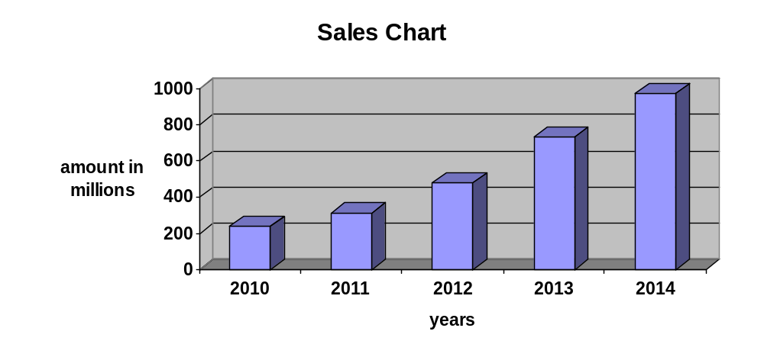
Inference:
The above table shows that the sales were very high in the year 2009 and the low sales in the year 2005. By this table we could understand that the sales of the company was varying year by year

Debtors Chart:

Years | Amount in Millions
2010 | 132.62
2011 | 125.96
2012 | 151.54
2013 | 317.95
2014 | 376.12

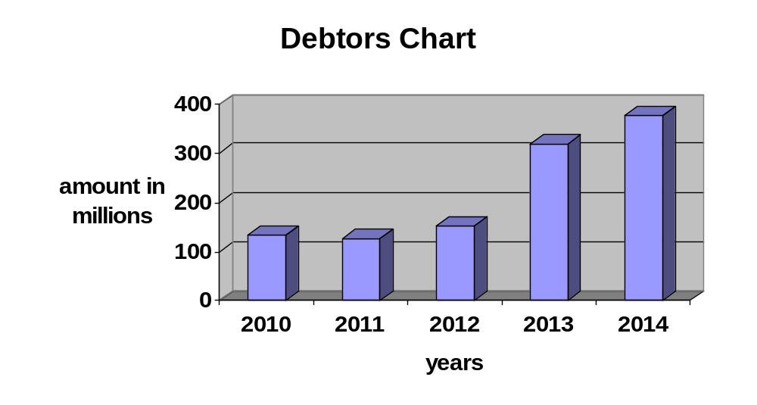
Inference:
The above table shows that the debtors were very high in the year 2009 and the low debtors in the year of 2005 By this table we could understand that the debtors of the company was varying year by year.

Receivables Chart
Years | Amount in rupees
2009-2010 | 2,548844
2010-2011 | 2,249,395
2011-2012 | 9,655,800
2012-2013 | 24,254,083
2013-2014 | 276,926,013
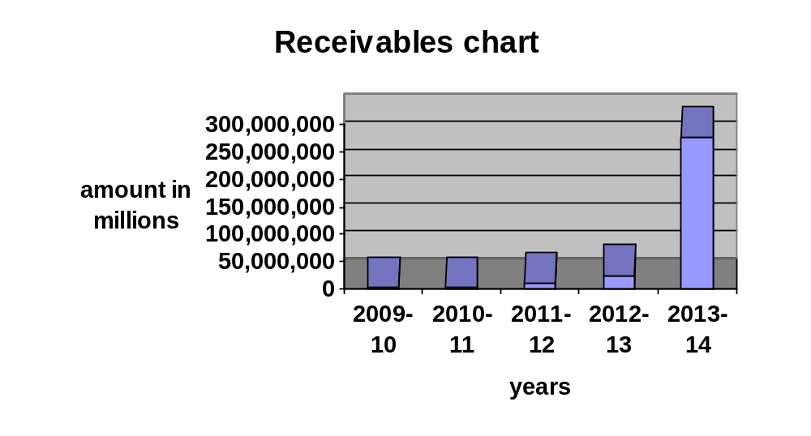
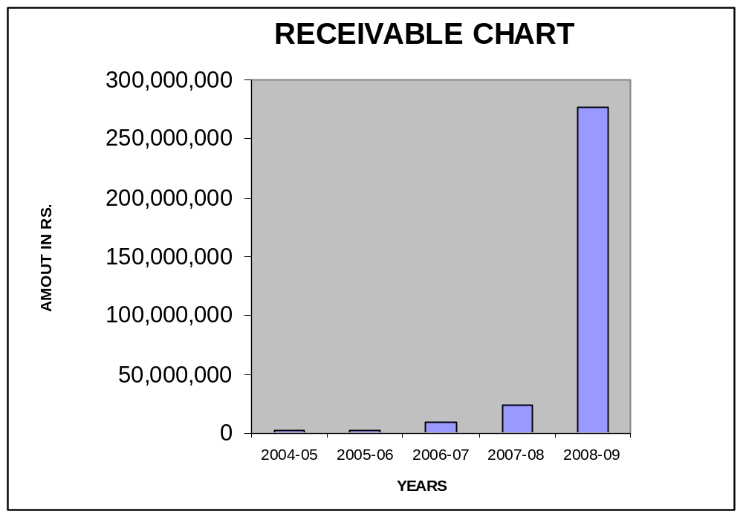
Inference:
The above table shows that the receivables were very high in the year 2008-09 and the low receivables in the year of 2004-2005 by this table we could understand that the debtors of the company was varying year by year.

Outstanding Receivables for 2009-2014:

Office | 2009-10 | 2010-11 | 2011-12 | 2012-2013 | 2013-14 | Grand Total
Chennai Branch Office |  | 2,828 | 25,000 | 282,144 | 17,865,525 | 18,175,497
Delhi Regional Office | 2,371,397 | 1,682,132 | 2,461,142 | 12,479,669 | 54,552,566 | 73,546,906
Hyderabad Branch Office | 138,481 |  | 1,334,437 | 4,547,991 | 71,718,287 | 77,739,196
Kolkata Branch Office | 23,648 |  | 5,322,675 | 3,225,889 | 70,078,592 | 78,653,804
Mumbai Regional Office |  | 496,654 | 502,546 | 2,762,887 | 51,383,583 | 55,145,670
Tirupati office | 15,318 | 67,781 |  | 955,503 | 11,327,460 | 12,76,062
TOTAL | 2,548844 | 2,249,395 | 9,655,800 | 24,254,083 | 276,926,013 | 304,537,135

Amara Raja Power Systems Ltd
Sector Wise Sales Details for the month of Mar - 2014
Sector | Mar-14 |  | Achiev  % | Variance
Sector | Budget | Actual | Achiev  % | Variance
Telecom | 15.00 | 7.26 | 48.38 | (7.74)
Railways | 30.00 | 76.29 | 254.30 | 46.29
PC | 45.00 | 46.57 | 103.50 | 1.57
Panels | 22.50 | 14.42 | 64.07 | (8.08)
Batteries | 28.26 | 23.41 | 82.85 | (4.85)
Projects | 35.00 |  | - | (35.00)
Service | 13.08 | 14.45 | 110.49 | 1.37
Others | 0.02 | 0.02 | - | -
 | 188.86 | 182.43 | 97 | (6.44)

Rs.In Millions
ACHIEVEMENT - 97%
15.00
30.00
45.00
22.50
28.26
35.00
13.08
0.02
7.26
76.29
46.57
14.42
23.41
14.45
0.02
-
10
20
30
40
50
60
70
80
90
Telecom
Railways
PC
Panels
Batteries
Projects
Service
Others
Mar-14 Budget
Mar-14 Actual

SEGMENTWISE MONTHLY SALES REPORT FOR ARPSL
Rs.In Millions
Month | Budget Actual | Amara Raja Power Systems Ltd. - 2013-14 |  |  |  |  |  |  |  |  | 2013-14 | 2012-13 | 2012-11
Month | Budget Actual | Telecom | Railway | Power | Panels | Battery Trading | Service | Projects | Others | Total | 2013-14 | 2012-13 | 2012-11
APR | Actual | 1.63 | 14.16 | 14.53 | - | 7.53 | 1.71 | - | - | 39.56 | 31.48 | 29.28 | 6.70
APR | Budget | 1.63 | 14.16 | 14.53 | - | 7.26 | 1.98 | - | - | 39.56 | 37.04 | 29.44 | 7.68
MAY | Actual | 1.51 | 16.65 | 16.90 | 0.31 | 11.90 | 2.61 | - | - | 49.89 | 42.22 | 24.06 | 13.15
MAY | Budget | 1.51 | 16.65 | 16.90 | 0.31 | 11.70 | 2.82 | - | - | 49.90 | 78.68 | 24.92 | 13.52
JUN | Actual | 1.37 | 35.00 | 14.01 | - | 7.70 | 2.39 | - | 0.09 | 60.55 | 49.33 | 37.50 | 25.25
JUN | Budget | 1.37 | 35.18 | 14.01 | - | 7.67 | 2.24 | - | 0.09 | 60.55 | 58.15 | 44.40 | 23.36
JUL | Actual | 0.12 | 47.02 | 6.76 | 0.76 | 8.33 | 2.23 | - | 0.06 | 65.28 | 39.51 | 39.97 | 33.34
JUl | Budget | 0.12 | 47.02 | 6.76 | 0.76 | 8.31 | 2.24 | - | 0.06 | 65.27 | 64.98 | 47.85 | 29.85
AUG | Actual | - | 25.24 | 19.50 | 0.31 | 5.59 | 1.57 | - | 0.03 | 52.24 | 41.75 | 35.00 | 27.10
AUG | Budget | - | 25.24 | 19.50 | 0.31 | 5.54 | 1.62 | - | 0.03 | 52.24 | 64.39 | 45.88 | 28.80
SEP | Actual | - | 6.14 | 20.86 | - | 6.06 | 5.30 | - | - | 38.37 | 61.18 | 40.70 | 41.27
SEP | Budget | - | 6.82 | 20.86 | - | 4.83 | 5.86 | - | - | 38.37 | 78.77 | 53.32 | 30.91
OCT | Actual | 1.09 | 13.26 | 11.53 | - | 13.28 | 8.83 | - | 0.04 | 48.04 | 50.52 | 60.30 | 31.61
OCT | Budget | 0.44 | 20.91 | 27.96 | 6.04 | 26.17 | 1.54 | - | 0.04 | 83.10 | 19.00 | 55.28 | 48.96
NOV | Actual | 2.57 | 58.66 | 8.97 | - | 10.99 | 5.73 | - | 0.07 | 87.00 | 68.44 | 37.61 | 29.19
NOV | Budget | 4.04 | 70.07 | 14.09 | 3.47 | 11.00 | 6.00 | - | 0.07 | 108.74 | 120.26 | 56.50 | 30.46
DEC | Actual | 2.26 | 13.46 | 23.10 | 0.17 | 12.14 | 6.82 | - | 0.07 | 58.02 | 71.06 | 41.62 | 41.36
DEC | Budget | 0.78 | 81.94 | 15.46 | 3.59 | 7.72 | 10.12 | - | 0.07 | 119.68 | 116.06 | 66.07 | 31.16
JAN | Actual | 0.43 | 26.14 | 9.15 | 2.49 | 7.22 | 6.13 | - | - | 51.56 | 83.49 | 20.11 | 42.07
JAN | Budget | 10.00 | 32.89 | 32.85 | 4.50 | 9.67 | 11.50 |  | 0.06 | 101.47 | 126.09 | 64.30 | 60.12
FEB | Actual | - | 47.40 | 14.99 | 10.28 | 7.79 | 3.51 | - | 0.06 | 84.04 | 52.93 | 78.96 | 28.06
FEB | Budget | 15.00 | 30.00 | 35.00 | 18.90 | 21.87 | 11.00 | 35.00 | - | 166.77 | 156.68 | 70.16 | 47.02
MAR | Actual | 7.3 | 76.3 | 46.6 | 14.4 | 23.4 | 14.5 | - | 0.0 | 182.43 | 223.15 | 159.29 | 83.09
MAR | Budget | 15.00 | 30.00 | 45.00 | 22.50 | 28.26 | 13.08 | 35.00 | 0.02 | 188.86 | 200.30 | 76.12 | 49.65
Total | Actual | 18.24 | 379.44 | 206.89 | 28.74 | 121.96 | 61.29 | - | 0.44 | 816.98 | 815.07 | 604.40 | 402.19
Total | Budget | 49.89 | 410.88 | 262.92 | 60.38 | 150.00 | 70.00 | 70.00 | 0.44 | 1,074.51 | 1,220.40 | 634.23 | 401.49
% OF ACHIEVEMENT  ON TOTAL BUDGET |  | 37% | 92% | 79% | 48% | 81% | 88% | 0% | 101% | 76.03% | 67% | 95% | 100%

FINDINGS
- The credit worthiness and credit limit of customer is determined by the character and financial position of a customers and period of presence in the business.
- The transactions with the new customers will be on cash terms, with due course of time, credit will be given to them.
- the company follows the classification of debts into three categories namely debts outstanding for less than 30-90 days are considered to be “GOOD”, for 90-180 days are considered to be “DOUBTFUL” and > 181 days are considered to be “DISPUTES”, >365 days are considered to be “bad debts”.
- The sales of the company on both cash and credit terms. Out of the sales generated 60% are of cash and 40%are of credit basis.
- No bad debts are seen in the year of September 2009 & February 2010.

SUGGESTIONS
- The company Structured frame work of bank Guarantee Limits must be done by the company that which extent the company may give credit limit to its customers.
- Implementation of special package of “EPR”, that which can improve the cash and credit management procedure in a better manner regarding to “ACCOUNTANTS RECEIVABLES”.
- Granting cash discount to encourage regular payments.
- If payments are delayed due to wrong billing, delayed billing etc., the billing system should be improved. (Reasonable time).
- If any customer is habitually defaulter in making payments, guarantee from a schedule must be taken.
- The company is reduced its bad debts .it can get extra receivables.
- If credit period is increased the collections can increases in sales.
CONCLSION
The receivable management systems followed by Amara Raja Power Systems Ltd shows satisfactory position. It gives to clear idea to the management to take decision. .The company is reduced its bad debts .it can get extra receivables. If credit period is increased the collections can increases in sales. Overall the financial performance of the company is good. And it has to take necessary steps to further growth of the company.

BALANCE SHEET AS 31st MARCH 2005
Particulars | As at 31.03.2005 |  | As at 31.03.2004
Particulars | Rupees | Rupees | Rupees | Rupees
SOURCES OF FUNDS
Shareholders Funds
Share Capital | 5,776,000 |  | 5,776,000
Reserves & Surplus | 84,607,661 |  | 95,235,016
 |  | 90,383,661 |  | 101,011,016
Loan Funds
Secured Loans | 84,057,525 |  | 51,530,721
Unsecured Loans | 36,545,567 |  | 62,248,197
 |  | 120,603,092 |  | 113,778,918
Deffered tax liability |  | 4,586,244 |  | 3,962,049
Total |  | 215,572,997 |  | 218,751,983
APPLICATION OF FUNDS
Fixed Assets
Gross Block | 55,785,742 |  | 55,048,970
Less: Depreciation | 19,406,799 |  | 17,211,150
Net block | 36,378,943 |  | 37,837,820
Capital Work-in-Progress | ----- |  | 366,093
 |  | 36,378,943 |  | 38,203,913
Investments |  | 456,000 |  | 456,000
Current Assets, Loans
& Advances
Inventories | 66,872,652 |  | 93,106,124
Sundry Debtors | 132,618,815 |  | 115,908,585
Cash & Bank Balances | 21,626,781 |  | 24,736,325
Loans, Advances | 14,695,533 |  | 68,430,457
 | 235,813,781 |  | 302,181,491
Less: Current Liabilities  & Provisions | 57,075,727 |  | 122,089,421
Net Current Assets |  | 178,738,054 |  | 180,092,070
Total |  | 215,572,997 |  | 218,751,983

BALANCE SHEET AS 31st MARCH 2006
Particulars | As at 31.03.2006 |  | As at 31.03.2005
Particulars | Rupees | Rupees | Rupees | Rupees
SOURCES OF FUNDS
Shareholders Funds
Share Capital | 5,776,000 |  | 5,776,000
Reserves & Surplus | 100,564,760 | 106,340,760 | 84,607,661 | 90,383,661
Loan Funds
Secured Loans | 66,371,662 |  | 84,057,525
Unsecured Loans | 38,860,170 | 105,231,832 | 36,545,567 | 120,603,092
Deffered tax liability |  | 4,758,706 |  | 4,586,244
Total |  | 216,331,298 |  | 215,572,997
APPLICATION OF FUNDS
Fixed Assets
Gross Block | 58,594,837 |  | 55,785,742
Less: Depreciation | 21,991,950 |  | 19,406,799
Net Block Capital Work-in-Progress | 36,602,887 |  | 36,378,943
 |  | 36,602,887 |  | 36,378,943
Investments |  | 9,504,211 |  | 456,000
Current Assets, Loans & Advances
Inventories | 53,133,187 |  | 66,872,652
Sundry Debtors | 125,961,671 |  | 132,618,815
Cash & Bank Balances | 41,712,910 |  | 21,626,781
Loans, Advances | 18,391,719 |  | 14,695,533
 | 239,199,487 |  | 235,813,781
Less: Current Liabilities & Provisions | 68,975,287 |  | 57,075,727
Net Current Assets |  | 170,224,200 |  | 178,738,054
Total |  | 216,331,298 |  | 215,572,997

BALANCE SHEET AS 31st MARCH 2007
Particulars | As at 31.03.2007 |  | As at 31.03.2006
Particulars | Rupees | Rupees | Rupees | Rupees
SOURCES OF FUNDS
Shareholders Funds
Share Capital | 5,776,000 |  | 5,776,000
Reserves & Surplus | 139,133,975 | 144,909,975 | 100,564,760 | 106,340,760
Loan Funds
Secured Loans | 69,305,043 |  | 66,371,662
Unsecured Loans | 11,673,920 | 80,978,963 | 38,860,170 | 105,231,832
Deffered tax liability |  | 4,967,207 |  | 4,758,706
Total |  | 230,856,145 |  | 216,331,298
APPLICATION OF FUNDS
Fixed Assets
Gross Block | 61,680,881 |  | 58,594,837
Less: Depreciation | 24,959,414 |  | 21,991,950
Net blockCapital Work-in-Progress | 36,721,467 |  | 36,602,887
Investments |  | 36,721,467 |  | 36,602,887
Current Assets, Loans &  Advances |  | 456,000 |  | 9,504,211
Inventories | 62,440,486 |  | 53,133,187
Sundry Debtors | 151,545,260 |  | 125,961,671
Cash & bank balances | 42,847,929 |  | 41,712,910
Loans, Advances & Deposits | 42,209,086 |  | 18,391,719
 | 299,042,762 |  | 239,199,487
Less: Current Liabilities &  Provisions | 105,364,083 |  | 68,975,287
Net Current Assets |  | 193,678,678 |  | 170,224,200
Total |  | 230,856,145 |  | 216,331,298

BALANCE SHEET AS AT 31st MARCH 2008
Particulars | As at 31.03.2008 |  | As at 31.03.2007
Particulars | Rupees | Rupees | Rupees | Rupees
SOURCES OF FUNDS
Shareholders Funds
Share Capital | 5,776,000 |  | 5,776,000
Reserves & Surplus | 192,396,080 |  | 139,133,975
 |  | 198,172,080 |  | 144,909,975
Loan Funds
Secured Loans | 115,269,169 |  | 69,305,043
Unsecured Loans | 11,673,920 |  | 11,673,920
 |  | 126,943,089 |  | 80,978,963
Deffered tax liability |  | 5,602,647 |  | 4,967,207
Total |  | 330,717,816 |  | 230,856,145
APPLICATION OF FUNDS
Fixed Assets
Gross Block | 70,034,504
Less: Depreciation | 28,442,773
Net block | 41,591,731
Capital Work-in-Progress | 790,000
 |  | 42,381,731 |  | 36,721,467
Investments |  | 456,000 |  | 456,000
Current Assets, Loans &
Advances
Inventories | 97,234,402 |  | 62,440,486
Sundry Debtors | 325,423,471 |  | 155,061,745
Cash & Bank Balances | 32,733,355 |  | 42,847,929
Loans, Advances & Deposits | 76,686,634 |  | 38,692,601
Less: Current Liabilities &  Provisions | 246,197,777 |  | 105,364,083
Net Current Assets |  | 287,880,086 |  | 193,678,678
Total |  | 330,717,816 |  | 230,856,145

BALANCE SHEET AS AT 31st MARCH 2009

Particulars | As at 31.03.2009 |  | As at 31.03.2008
Particulars | Rupees | Rupees | Rupees | Rupees
SOURCES OF FUNDS
Shareholders Funds
Share Capital | 17,328,000 |  | 5,776,000
Reserves & Surplus | 210,888,272 |  | 192,396,080
 |  | 228,216,272 |  | 198,172,080
Loan Funds
Secured Loans | 91,595,683 |  | 115,269,169
Unsecured Loans | 11,673,920 |  | 11,673,920
 |  | 103,269,603 |  | 126,943,089
Deffered tax liability |  | 2,090,590 |  | 5,602,647
Total |  | 333,576,465 |  | 330,717,816
APPLICATION OF FUNDS
Fixed Assets
Gross Block | 77,533,101 |  | 70,034,505
Less: Depreciation | 28,986,155 |  | 28,442,774
Net block |  | 48,546,946 |  | 41,591,731
Capital Work-in-Progress |  | 790,000 |  | 790,000
Investments |  | 456,000 |  | 456,000
Current Assets, Loans &
Advances
Inventories | 95,359,669 |  | 97,234,402
Sundry Debtors | 376,128,492 |  | 317,915,356
Cash & Bank Balances | 16,318,356 |  | 32,733,358
Loans, Advances & Deposits | 118,222,950 |  | 86,193,246
 |  | 606,029,467 |  | 534,076,362
Less: a. Current Liabilities | 213,436,209 |  | 177,454,005
b. Provisions | 108,809,739 |  | 68,742,272
 |  | 322,245,948 |  | 246,196,277
Net Current Assets |  | 283,783,519 |  | 287,880,085
Total |  | 333,576465 |  | 330,717,816

PROFIT AND LOSS ACCOUNT FOR THE YEAR ENDED
31stMARCH 2010
Particulars | Year Ended on  31.03.10 Rupees | Year Ended on  31.03.09 Rupees
INCOME
Sales | 238,000,904 | 33,601,680
Other Income | 11,846,955 | 14,149,680
Increase / (Decrease) in stocks | (17,448,587) | 6,930,588
Total | 232,399,272 | 354,681,948
Expenditure
Raw Material Consumed | 135,531,887
Payments & Benefits to Employees | 29,238,841 | 188,605,718
Manufacturing Expenses | 4,847,073 | 34,916,533
Selling expenses | 14,154,252 | 7,315,729
Administration expenses | 12,171,544 | 17,744,715
Taxes & duties | 135,065,606 | 20,314,336
Financial charges | 9,156,027 | 45,687,482
Depreciation | 2,195,649 | 18,406,065
Total | 242,660,878 | 2,836,154
Profit Before Taxation | (10,261,606) | 18,855,216
Add: Excess provision in earlier years | 1,364,254
Less: provision for taxation | ---- | 5,500,000
Deffered tax liability | 624,195 | 1,062,756
Profit After Taxation | (9,521,547) | 12,292,460
Add:Profit / (loss) b/f from previous years | 77,815,195 | 69,058,558
Profit available for appropriation | 68,293,648 | 81,351,018
Less: Appropriation
Transfer to General Reserve | ------ | 1,250,000
Proposed dividend | 577,600 | 2,021,600
Dividend tax | 81,008 | 264,223
Net profit carried to balance sheet | 67,635,040 | 77,815,195

PROFIT AND LOSS ACCOUNT FOR THE YEAR ENDED
31st MARCH 2011
Particulars | Year Ended on  31.03.11 Rupees | Year Ended on  31.03.10 Rupees
INCOME
Sales | 313,497,275 | 238,,000,904
Other Income | 12,242,032 | 11,846,955
Increase / (Decrease) in stocks | (12,757,889) | (17,448,587)
Total | 312,981,418 | 232,399,272
Expenditure
Raw Material Consumed | 166,952,521 | 135,531,887
Payments & Benefits to Employees | 27,097,711 | 29,238,841
Manufacturing Expenses | 4,975,957 | 4,847,073
Selling expenses | 16,275,204 | 14,154,252
Administration expenses | 13,060,416 | 12,471,544
Taxes & duties | 50,525,031 | 35,065,606
Financial charges | 8,541,299 | 9,156,027
Depreciation | 2,585,151 | 2,195,649
Total | 290,013,290 | 242,660,878
Profit Before Taxation | 22,968,128 | (10,261,606)
Add: Excess provision in earlier years | ------ | 1,364,254
Less: provision for taxation | 4,229,668 | ----
Provision for fringe Benefit Tax | 695,636 | ----
Deffered tax liability | 172,462 | 624,195
Profit After Taxation | 17,870,361 | (9,521,547)
Add: Profit / (loss) b/f from previous years | 67,635,040 | 77,815,195
Profit available for appropriation | 85,505,401 | 68,293,648
Less: Appropriation
Transfer to General Reserve | 1,800,000 | ----
Proposed dividend | 2,021,600 | 577,600
Dividend tax | 283,529 | 81,008
Net profit carried to balance sheet | 81,400,272 | 67,635,040

PROFIT AND LOSS ACCOUNT FOR THE YEAR ENDED 31st MARCH 2012

Particulars | Year Ended on  31.03.12Rupees | Year Ended on  31.03.11 Rupees
INCOME
Sales | 478,422,373 | 323,769,616
Other Income | 5,469,791 | 1,857,822
Increase / (Decrease) in stocks | 17,729,162 | (12,757,889)
Total | 501,621,726 | 312,869,549
Expenditure
Raw Material Consumed | 262,336,266 | 168,519,138
Payments & Benefits to Employees | 35,458,006 | 27,097,711
Manufacturing Expenses | 3,658,818 | 3,409,340
Selling expenses | 25,205,102 | 16,275,204
Administration expenses | 20,082,430 | 12,948,547
Taxes & duties | 79,021,448 | 50,525,031
Financial charges | 8,380,203 | 8,541,299
Depreciation | 2,967,464 | 2,585,151
Total | 437,109,737 | 289,901,421
Profit Before Taxation | 64,511,989 | 22,968,128
Add: Excess provision in earlier years | ----- | ------
Less: Provision for taxation | 21,439,490 | 4,229,668
Provision for fringe Benefit Tax | 295,537 | 695,636
Differed tax liability | 208,501 | 172,462
Profit After Taxation | 42,568,461 | 17,870,361
Add: Profit / (loss) b/f from previous years | 81,400,272 | 67,635,040
Profit available for appropriation | 123,968,733 | 85,505,401
Less: Appropriation
Transfer to General Reserve | 4,256,846 | 1,800,000
Proposed dividend | 3,465,600 | 2,021,600
Dividend tax | 588,979 | 283,529
Net profit carried to balance sheet | 115,657,308 | 81,400,272

PROFIT AND LOSS ACCOUNT FOR THE YEAR ENDED
31st MARCH 2013
Particulars | Year Ended on 31.03.13 Rupees | Year Ended on  31.03.12 Rupees
INCOME
Gross Sales | 730,780,437 | 478,422,373
Less: Duties & taxes | 126,359,234 | 78,179,256
Net sales | 604,421,203 | 399,400,925
Total
Expenditure
Raw Material Consumed | 390,304,827 | 262,336,266
Increase (+)/Decrase (-) in stocks | 25,671,667 | 17,729,562
Material Consumed | 364,633,160 | 244,606,704
Payments & Benefits to Employees | 48,688,877 | 35,458,006
Manufacturing Expenses | 4,769,975 | 3,658,818
Selling expenses | 22,522,499 | 25,205,102
Administration expenses | 49,688,877 | 20,082,430
Taxes & duties | 7,402,761 | 842,192
Financial charges | 7,371,761 | 8,380,203
Depreciation | 3,483,360 | 2,967,464
Total Expenditure | 512,623,611 | 340,358,727
Income from operations | 91,767,592 | 59,042,199
Other income | 2,110,031 | 5,469,791
Profit Before Taxation | 93,907,623 | 64,511,990
Add: Excess provision in earlier years | ----- | ------
Less: Provision for taxation | 31,800,000 | 21,439,490
Provision for fringe Benefit Tax | 820,000 | 295,537
Differed tax liability | 635,440 | 208,501
Profit After Taxation | 60,652,183 | 42,568,462
Add: Profit / (loss) b/f from previous years | 115,657,309 | 81,400,272
Profit available for appropriation | 176,309,492 | 123,968,734
Less: Appropriation
Transfer to General Reserve | 6,065,218 | 4,256,846
Proposed dividend | 4,332,000 | 3,465,600
Dividend tax | 736,223 | 588,979
Net profit carried to balance sheet | 165,176,050 | 115,657,309

PROFIT AND LOSS ACCOUNT FOR THE YEAR ENDED
31st MARCH 2014
Particulars | Year Ended on  31.03.14 Rupees | Year Ended on  31.03.13 Rupees
INCOME
Gross Sales | 971,372,396 | 730,780,437
Less: Duties & taxes | 124,610,958, | 126,359,234
Total | 846,761,438 | 604,421,203
Expenditure
Raw Material Consumed | 570,465,014 | 392,385,100
Increase (+)/Decrease (-) in stocks | 4,447,356 | (25,671,667)
Material Consumed | 574,912,370 | 366,713,433
Payments & Benefits to Employees | 74,821,584 | 48,688,877
Manufacturing Expenses | 6,673,111 | 4,769,975
Selling expenses | 27,219,384 | 16,222,462
Administration expenses | 63,338,214 | 53,685,671
Other expenses | 10,920,622 | 6,365,584
Taxes & duties | 23,055 | 5,322,488
Financial charges | 12,199,895 | 7,371,761
Depreciation | 3,774,654 | 3,483,360
Total Expenditure | 773,882,889 | 512,623,611
Income from operations | 72,878,549 | 91,797,592
Other income | 2,052,126 | 2,110,031
Profit Before Taxation | 74,930,675 | 93,907,623
Add: Excess provision in earlier years | ------ | ------
Less: Provision for taxation | ------- | ------
Current Tax | 29,300,000 | 31,800,000
Provision for fringe Benefit Tax | 1,122,000 | 820,000
Differed tax liability | (3,512,057) | 635,440
Earlier years short provision | 3,131,093 | -------
Profit After Taxation | 44,889,639 | 60,652,183
:Profit / (loss) b/f from previous years | 165,176,051 | 115,657,309
Profit available for appropriation | 210,065,690 | 176,309,492
Less : Appropriation
Transfer to General Reserve | 4,488,964 | 6,065,218
Proposed dividend | 12,996,000 | 4,332,000
Dividend tax | 2,208,670 | 736,223
Net profit carried to balance sheet | 190,372,056 | 165,176,051

BIBLIOGRAPHY
- M.Y. Khan & P.K. Jain (2007) financial management: Text, Problems & Cases, 4/e, Tata McGraw-Hill publications: New Delhi.
- .I.M. Pandey (2004), financial management, 9/e, Vikas publications,
New Delhi.
- Prasanna Chandra (2003), Financial Management, 5/e,
Tata McGraw-Hill Publication: New Delhi.
- http://www.amararaja.co.in.
- http://www.arpsl.co.in

